SUNDAY | MONDAY | TUESDAY | WEDNESDAY | THURSDAY | FRIDAY | SATURDAY
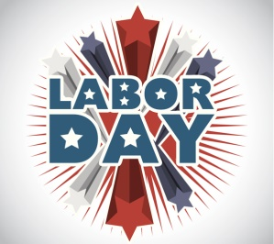 | 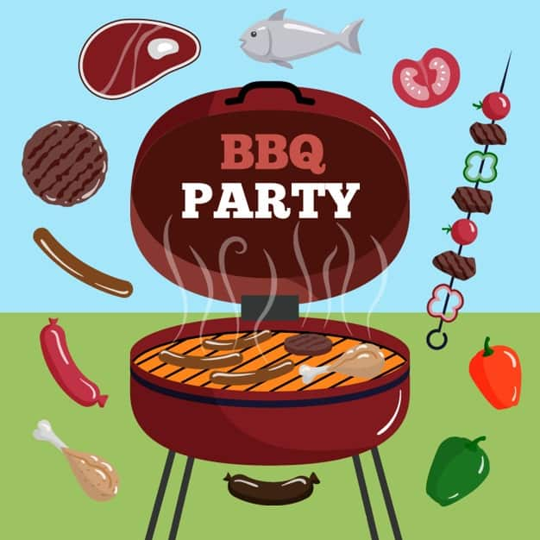 |  | 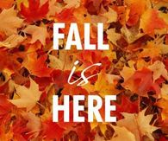 | 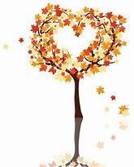 | 1  Arts, Beats & Eats in Royal Oak  6:00-9:00pm | 2  Jazz Festival @ Hart Plaza  12:00-3:00pm
3  Michigan State Fair @ Suburban Showplace in Novi  12:00-3:00pm | 4  Labor Day BBQ @ OLH3  12:00-2:30pm | 5  Walk @ Park & Slurpee  5:00-6:30pm | 6  “Anything Goes” Dinner @ OLH3  4:30-6:30pm | 7  Bingo on Zoom  6:00pm | 8  Baseball Game @ Jimmy John’s Field  7:00pm | 9  Brighton’s Smokin Jazz & BBQ Blues Festival  5:00-7:30pm
10  Art & Apples Festival in Rochester Hills  12:00-2:30pm | 11  Bowling @ Perfect Game  6:00-8:00pm  Bowling League 6:30pm | 12  Tiger’s Game  6:40pm | 13  “Anything Goes” Dinner @ OLH3  4:30-6:30pm | 14  Lunch & Music in Southfield  11:30am-2pm  Library 5:00-6:30pm | 15  Cider Mill  5:00-6:30pm  Happy Birthday Mark! | 16  Detroit Auto Show  12:00-3:30pm
17  Lou Crank Wrestling in Garden City  6:30pm | 18  Bowling @ Perfect Game  6:00-8:00pm  Bowling League 6:30pm | 19  Out to Eat  4:30-6:30p  *Clients pay for their own meal* | 20  “Anything Goes” Dinner @ OLH3  4:30-6:30pm | 21  Comedy Castle  7:30pm  Happy Birthday Eddie! | 22  Oktoberfest in Redford  6:00-8:00pm  *Music, food, vendors* | 23  DIY Street Fair in Ferndale  12:00-3:00pm  *Vendors, food*
24  Car Show & DQ @ Bakers in Milford  2:00-4:00pm  Happy Birthday Patty! | 25  Bowling @ Perfect Game  6:00-8:00pm  Bowling League 6:30pm | 26  Bingo & Snacks @ OLH2  6:00-8:00pm | 27  “Anything Goes” Dinner @ OLH3  4:30-6:30pm  Happy Birthday Perry! | 28  Trivia Night on Zoom  6:00pm | 29  Movie Theater  Time TBD | 30  Shorestoberfest @ Veteran Park  6:00-8:00pm  *Music, food, vendors*  Happy Birthday Maria!

