SUNDAY | MONDAY | TUESDAY | WEDNESDAY | THURSDAY | FRIDAY | SATURDAY
1  Michigan State Fair in Novi  12:30-3:30pm | 2  Labor Day BBQ @ OLH3  12:00-2:30pm | 3  Bowling 2:00pm  Make Bath Bombs for BIA & Dinner @ OLH2 4:15-6:15p | 4  Adapted Yoga @ OLH2 2:00pm  Art Teacher & Dinner @ OLH  5:00-7:00pm | 5  Bingo @ Costick Center 1:15pm  *50 & Older*  Library  5:00-6:30pm | 6  Baseball Game @ Jimmy John’s Field & Fireworks  7:00pm | 7  Brighton’s Smokin Jazz & BBQ Blues Festival  5:00-8:00pm
8  Arts & Apple Festival in Rochester Hills  1:00-3:00pm | 9  Bible Study @ OLH  10:00am  Bowling League  6:30pm | 10  Bowling 2:00pm  Make Bath Bombs for BIA & Dinner @ OLH2 4:15-6:15p | 11  Adapted Yoga @ OLH2 2:00pm  Bingo & Dinner @ OLH  5:00-7:00pm | 12  BIA Dinner Dance in Lansing  6:00-10:00pm  *Please dress nicely* | 13  BBQ & Game Night @ Each House  5:00-7:00pm | 14  Movie Theater  Time TBD
15  Moon Over Buffalo Play @ Village Players 2:00pm  *Comedy*  Happy Birthday Mark K!! | 16  Bible Study @ OLH  10:00am  Bowling League  6:30pm | 17  Bowling 2:00pm  Make Treats/Goody Bags the Homeless @ OLH2  5:30-7:00pm | 18  Adapted Yoga @ OLH2 2:00pm  Art Teacher & Dinner @ OLH  5:00-7:00pm | 19  Bingo @ Costick Center 1:15pm  *50 & Older*  YMCA  5:00-6:30pm  *Times can vary* | 20  Tigers Game & Fireworks  7:00pm | 21  Feeding Homeless in Detroit  12:00pm  Happy Birthday Eddie C!!
22  DIY Street Fair in Ferndale  1:00-3:00pm | 23  Bible Study @ OLH  10:00am  Bowling League  6:30pm | 24  Bowling 2:00pm  Happy Birthday Patty C!!  Walk @ Local Park or in neighborhood  5:30-7:00pm | 25  Auto No Fault Rally in Lansing!!  8:00-2:00pm  Happy Birthday Brian!  Bingo & Dinner @ OLH 5:00-7:00pm | 26  Bingo @ Costick Center 1:15pm  *50 & Older*  Karaoke at Shield’s Pizza 8:00pm | 27  Sterling Heights Dance  6:30-9:30pm | 28  Cider Mill/Apple Orchard  1:00-3:00pm
29  Church  Time TBD | 30  Bible Study @ OLH  10:00am  Happy Birthday Maria H!!  Bowling League  6:30pm | 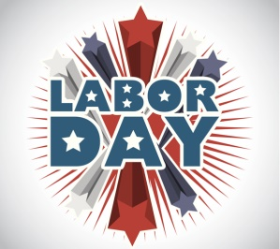 | 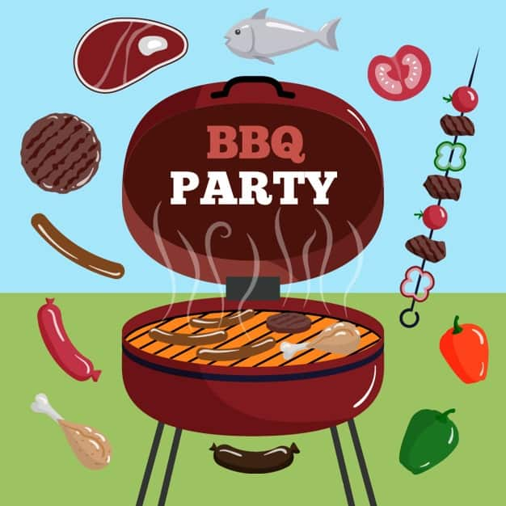 |  | 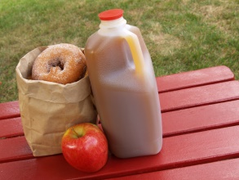 | 