SUNDAY | MONDAY | TUESDAY | WEDNESDAY | THURSDAY | FRIDAY | SATURDAY
1  Decorate Houses for Halloween  5:00-7:00pm  *Pizza party for best house!* | 2  Bowling @ Perfect Game  6:00-8:00pm  Bowling League 6:30pm | 3  Auto No Fault Rally in Lansing!!  ALL HANDS ON DECK!  *Food will be provided* | 4  “Anything Goes” Dinner @ OLH3  4:30-6:30pm | 5  Bingo on Zoom  6:00pm | 6  “A Jukebox for the Algonquin” Play @ Farmington Players Barn  8:00pm  *Comedy” | 7  Detroit Harvest Fest & Food Truck Rally 12:00-3:00pm  *50+ food trucks, music & more!*
8  Piston’s Game  @ LCA  3:00pm | 9  Bowling @ Perfect Game  6:00-8:00pm  Bowling League 6:30pm | 10  Fall Color Walk @ Heritage Park  5:00-6:30pm | 11  “Anything Goes” Dinner @ OLH3  4:30-6:30pm | 12  Halloween Cookie Decorating & Games @ OLH2  5:30-7:30pm  Happy Birthday Lori! | 13  Comedy Castle  7:00pm | 14  Michigan Makers Market @ The Hawk 1:00-3:00pm  *Arts & Crafts Fair*
15  Cider in the City @ Beacon Park  1:00-3:00pm  *Food trucks, lawn games, hayrides* | 16  Bowling @ Perfect Game 6:00-8:00pm  Happy Birthday Charlene!  Bowling League 6:30pm | 17  Bingo & Snacks @ OLH2  6:00-8:00pm | 18  “Anything Goes” Dinner @ OLH3  4:30-6:30pm | 19  Trivia Night on Zoom  6:00pm | 20  Movie Theater  Time TBD | 21  Haunted Hayride/House  8:00pm
22  Pumpkin Carving & Painting Contest @ OLH2  12:00-2:00pm  *Prizes for best pumpkins!* | 23  Bowling @ Perfect Game  6:00-8:00pm  Bowling League 6:30pm | 24  Library  5:00-6:30pm | 25  “Anything Goes” Dinner @ OLH3  4:30-6:30pm | 26  Out to Eat  4:30-6:30p  *Clients pay for their own meal* | 27  Sterling Heights Halloween Dance  6:00-9:00pm | 28  Chili & Game Night @ OLH2  1:00-3:00pm
29  Halloween Movie Marathon & Pizza @ OLH2 4:30-9:00pm  *2 movies & pizza party* | 30  Bowling @ Perfect Game 6:00-8:00pm  Happy Birthday Deborah H!  Bowling League 6:30pm | 31  Halloween Party @ OLH3 4:30-6:30pm  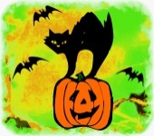 | 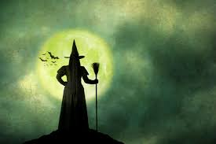 | 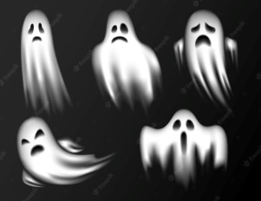 | 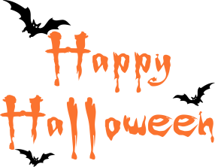 | 