SUNDAY | MONDAY | TUESDAY | WEDNESDAY | THURSDAY | FRIDAY | SATURDAY
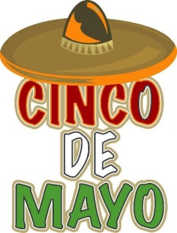 | 1  Bowling @ Perfect Game  6:00-8:00pm | 2  Mall or Neighborhood Walk  5:30-7:00pm | 3  “Anything Goes” Dinner @ OLH3  4:30-6:30pm | 4  Bingo on Zoom  6:00pm | 5  Cinco De Mayo @ OLH3 4:30-6:30pm  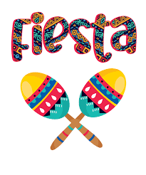  Happy Birthday  Steve L! | 6  Treasure Hunters Market @ Dodge Park  11:00am-1:30pm
7  Fiesta Detroit  5:00-7:00pm  *Live music, food, arts* | 8  Bowling @ Perfect Game  6:00-8:00pm  Happy Birthday Shaheedah! | 9  H.E.A.T Fitness Group with Maureen @ OLH4  6:00-7:30pm  *Healthy Eating & Toning* | 10  “Anything Goes” Dinner @ OLH3  4:30-6:30pm  Hip-Prov @ Ant Hall  8:00pm | 11  BIA Support Group @ Botsford  7:00pm | 12  Ferndale Vintage Fashion Market @ Rust Belt  5:00-7:00pm  *Various vendors, marketplace* | 13  United States Football League (USFL) Game @ Ford Field  12:30pm
14  Game Day with Danielle @ OLH3  1:00-3:00pm | 15  Bowling @ Perfect Game  6:00-8:00pm  Happy Birthday Kathy! | 16  Capital Day in Lansing!!  All Day! | 17  “Anything Goes” Dinner @ OLH3  4:30-6:30pm | 18  Movie Theater  Time TBD  Happy Birthday Darryl & Danishal! | 19  Jimmy Johns Baseball Game & Fireworks  7:00pm | 20  Assumption Church Garage Sale in St. Clair Shores  11:00am-1:30pm
21  Lu Crank Wrestling Match  6:30pm | 22  Bowling @ Perfect Game  6:00-8:00pm | 23  Bingo & Snacks @ OLH2  6:00-8:00pm  Happy Birthday Leonia! | 24  “Anything Goes” Dinner @ OLH3  4:30-6:30pm | 25  Trivia Night on Zoom  6:00pm | 26  Tigers Game & Fireworks  6:30pm | 27  Kensington Park  Art Fair in Milford  12:00-2:30pm
28  RESPECT!  A Tribute to Aretha Franklin @ The Detroit Symphony Orchestra  3:00pm | 29  Memorial Day Party @ OLH3  12:00-2:30pm | 30  Out to Eat  4:30-6:30pm  *Clients pay for their own meal* | 31  “Anything Goes” Dinner @ OLH3  4:30-6:30pm |  | 