SUNDAY | MONDAY | TUESDAY | WEDNESDAY | THURSDAY | FRIDAY | SATURDAY
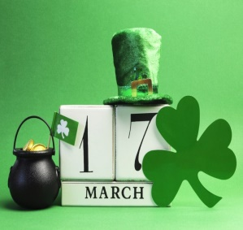 | 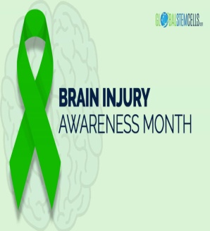 |  | 1  “Anything Goes” Dinner @ OLH3  4:30-6:30pm | 2  Bingo on Zoom  6:00pm | 3  Dinner & Dueling Piano Bar in Royal Oak 6:30-9:00pm  *Live Music Hits to Sing/Dance to! Clients Pay for own meal* | 4  Dixieland Flea Market  11:00-2:00pm
5  Shoot Pool @ OLH3  1:00-3:00pm  Happy Birthday  Erick & Lesa!! | 6  Bowling @ Perfect Game 6:00-8:00pm  Bowling League 6:30pm | 7  H.E.A.T Group with Maureen @ OLH4  6:00-7:30pm  Happy Birthday Byron!! | 8  “Anything Goes” Dinner @ OLH3  4:30-6:30pm  Hip-Prov @ Ant Hall  8:00pm | 9  Piston’s Game  7:00pm  *Must Commit when Signing up! | 10  Out to Eat  4:30-6:30pm  *Clients pay for their own meal*  Happy Birthday Tony!! | 11  Monster Jam @ Ford Field  7:00pm
12  St. Patrick’s Day Parade in Detroit 1:00pm | 13  Bowling @ Perfect Game 6:00-8:00pm  Bowling League 6:30pm | 14  Library  5:00-6:30pm  *Times can vary* | 15  “Anything Goes” Dinner @ OLH3  4:30-6:30pm | 16  BIA Memory Support Group on Zoom  3:00pm | 17  St. Patty’s Day Party @ OLH3  4:30-6:30pm | 18  “Lend Me A Tenor” @ Birmingham Village Players 8:00pm  *Comedy*
19  Go Comedy! Improv in Ferndale  7:00pm | 20  Bowling @ Perfect Game 6:00-8:00pm  Bowling League 6:30pm | 21  H.E.A.T Group with Maureen @ OLH4  6:00-7:30pm | 22  “Anything Goes” Dinner @ OLH3  4:30-6:30pm | 23  “Ants in the Hall” Improv @ Ant Hall  8:00pm | 24  Motor City Cruise Basketball Game  (NBA G-League)  7:00pm | 25  Comedy Castle in Royal Oak  7:00pm
26  Karaoke & Snacks @ OLH4  5:30-7:30pm | 27  Bowling @ Perfect Game 6:00-8:00pm  Bowling League 6:30pm | 28  Bingo & Snacks @ OLH2  5:00-7:00pm | 29  “Anything Goes” Dinner @ OLH3  4:30-6:30pm | 30  Trivia Night on Zoom  6:00pm | 31  Bees Knees Pottery  1:00pm  Movie Theater  Time TBD | 