SUNDAY | MONDAY | TUESDAY | WEDNESDAY | THURSDAY | FRIDAY | SATURDAY
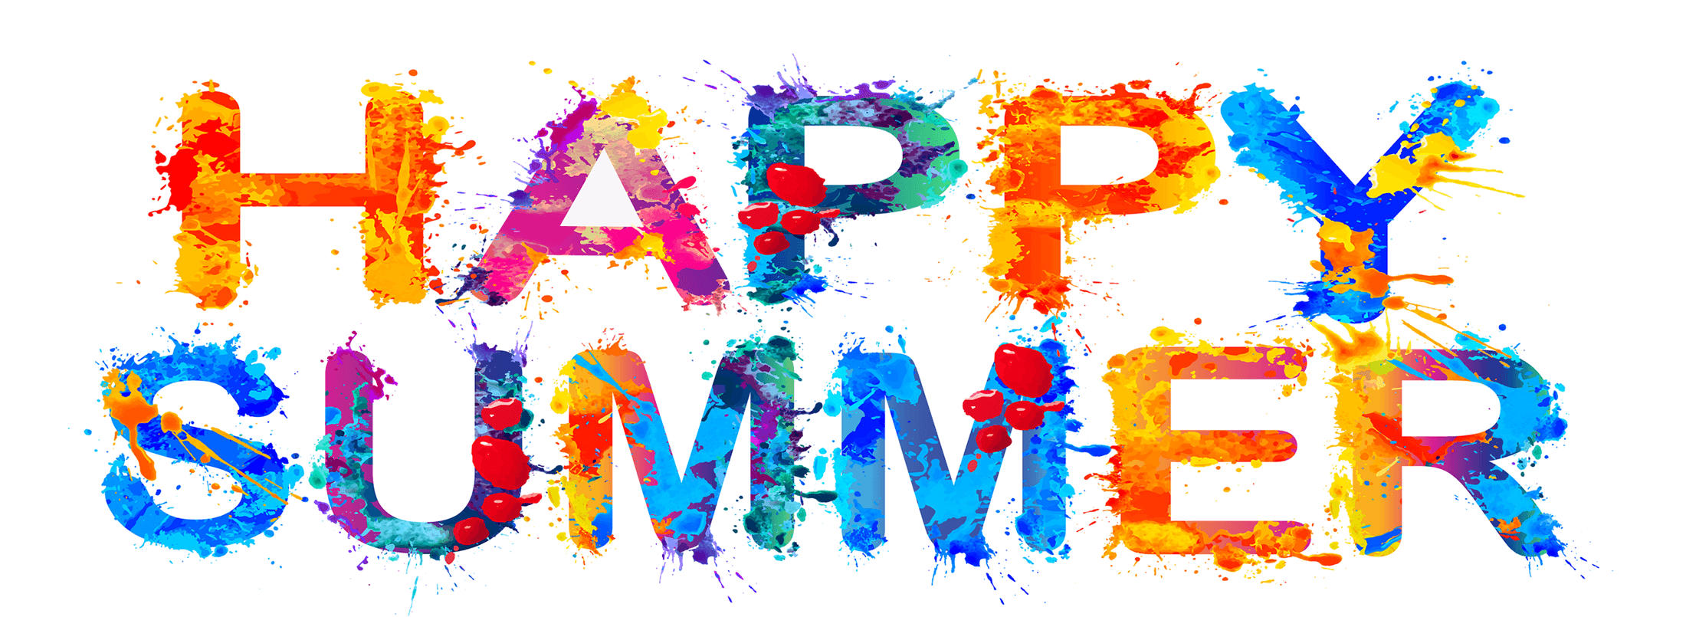 | 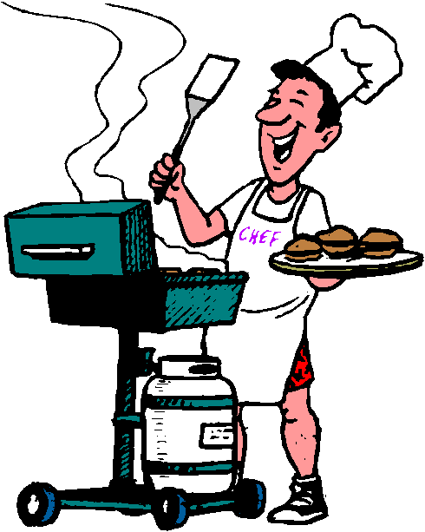 |  |  | 1  Bingo on Zoom  6:00pm  Happy Birthday Steve C! | 2  Centerline Festival @ Memorial Park  6:00-9:00pm  *Music, food, etc.* | 3  Crusin’ 53 @ Warren City Hall  11:30am-1:30pm  *Car Show, music, food*
4  Art on the Grand Festival in Farmington Hills  1:00-3:00pm  *Art, Food & Vendors* | 5  Bowling @ Perfect Game  6:00-8:00pm | 6  Mall or Neighborhood Walk  5:30-7:00pm  Happy Birthday  DJ M!! | 7  “Anything Goes” Dinner @ OLH3  4:30-6:30pm | 8  Atomic Radio (Dance/Rock Music) @ Dodge Park 7:00pm  *Music, food trucks, farmers market* | 9  The Detroit Youth Choir @ The Hawk  7:00pm  *Came in 2nd place on America’s Got Talent!* | 10  Berkley Art Bash  1:00-3:00pm  *Music, Art, Food & Vendors*
11  Game Day with Danielle @ OLH3  1:00-3:00pm | 12  Bowling @ Perfect Game  6:00-8:00pm | 13  Diamond Jack Boat Tour  6:00-7:30pm | 14  “Anything Goes” Dinner @ OLH3  4:30-6:30pm  Hip-Prov @ Ant Hall  8:00pm | 15  Trivia Night on Zoom  6:00pm | 16  Outdoor Movie-The Breakfast Club @ New Center Park in Detroit  8:00-11:00pm | 17  Birch Run Lunch & Shopping  11:00am-3:00pm  *Clients pay for lunch & shopping*
18  United States Football League Michigan Panthers @ Ford Field 7:00pm | 19  Tiger’s Game  6:40pm | 20  Out to Eat  4:30-6:30pm  *Clients pay for their own meal* | 21  “Anything Goes” Dinner @ OLH3  4:30-6:30pm | 22  Movie Theater  Time TBD | 23  Jimmy Johns Baseball Game & Fireworks  7:00pm | 24  Annual Michigan Balloonfest in Howell  5:00-8:00pm  *Hot Air Balloon Launch, festival, food & vendors*
25  TLC & Shaggy Concert @ Pine Knob  7:00pm | 26  Bowling @ Perfect Game  6:00-8:00pm | 27  Bingo & Snacks @ OLH2  6:00-8:00pm | 28  “Anything Goes” Dinner @ OLH3  4:30-6:30pm | 29  Simply Queen (Queen Tribute Band) @ Dodge Park 7:00pm  *Music, food trucks, farmers market* | 30  Dinner & Cancel Monday (Current, Variety, Pop Music) @ Partridge Creek Mall 5:00-8:00pm  *Clients pay for own meal* | 